Team Project

# Assignment list

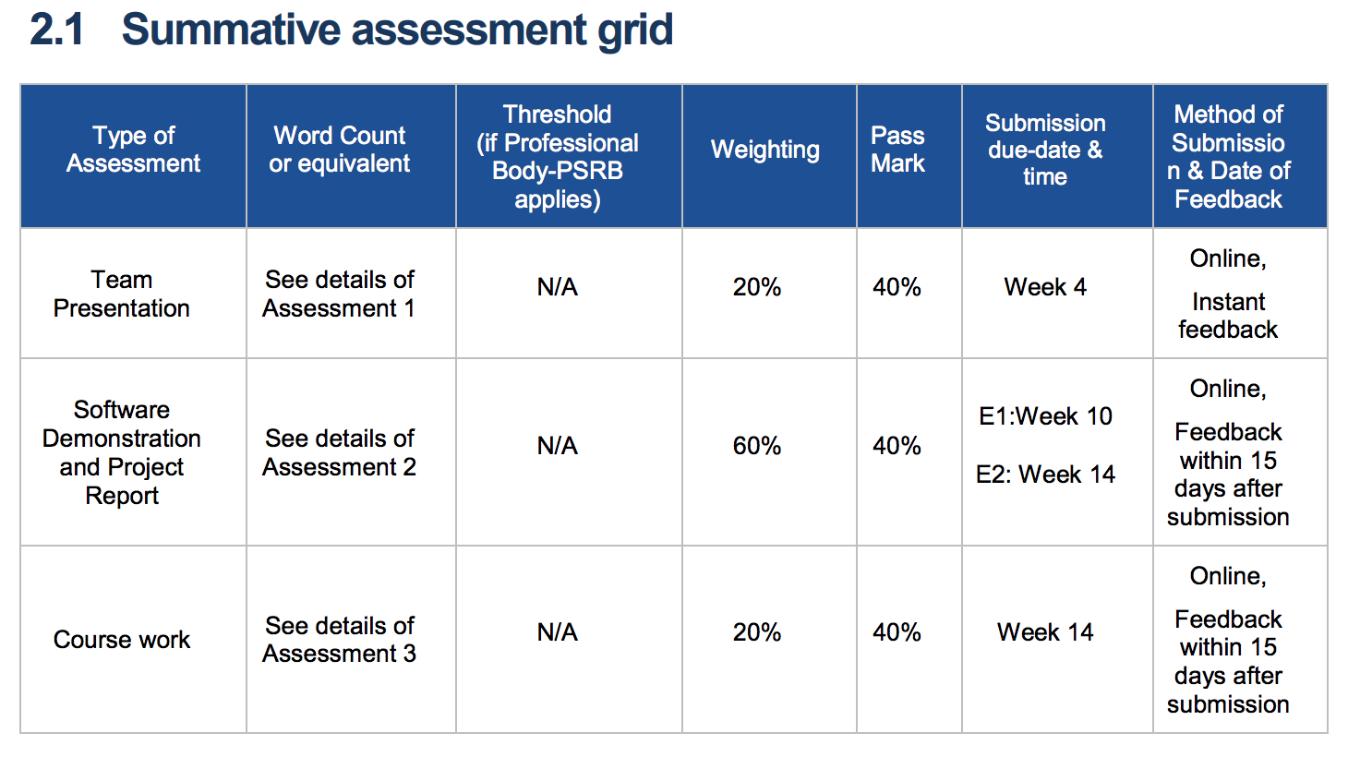

There are 3 assignments:

* Team Presentation – 20%
* Software Demonstration & Project Report – 60%
* Course Work – 20%

# Assignment 1: Team Presentation

For this assessment, students are expected to produce a team presentation which includes:

* **Software development plan** 
  + Project purpose
  + Scope
  + Overview
  + Roles and responsibilities
  + How we are going to create the website
    - Technical and non-technical steps, etc…
* **Functional modules separation of the software**
  + No idea what this means (I’ve emailed Dr. Zhang asking what it means)
* **Corresponding solutions of each module**
  + No idea what this means (I’ve emailed Dr. Zhang asking what it means)
* **It is also expected to cover the team development task aimed at developing the “core” module of the software.**
  + No idea what this means (I’ve emailed Dr. Zhang asking what it means)

As part of this assessment, students are expected to have completed the following:

* **As a team, develop the initial requirements for the core.** 
  + Don’t know what the “core” means. I’m assuming it’s talking about the website.
  + Technical, non-technical requirements, system requirements??? No idea.
* **As a team member, contribute to the development of the core.**
* **As a team, support the project manager to produce a project plan (Gantt chart, Critical path analysis (CPA), allocate resources, baseline it).** 
  + A project plan is a formal document designed to guide the control and execution of a project.
    - A Gantt chart is a type of bar chart that illustrates a project schedule.
    - CPA is an algorithm chart for scheduling a set of project activities.
    - Allocating resources – what we need to complete this project
      * i.e. Who we need (explaining each of our roles)
      * How long we need to completely finish the project
      * Requirements to complete the project (e.g. a specific software)
      * “Baseline it” – I’m assuming it means to write a minimum standard in what we would want to achieve, etc.
* **As a team, provide minutes of team meetings.** 
  + We will somehow record our team meetings, we will explain what we did during the meetings, how long they were, when they were, etc…
* **For your chosen role, describe the tasks, the solutions and responsibilities.** 
  + Each person will have a role
    - Write what your role is, explain your role, state your tasks and explain them and your responsibilities, solutions, etc…
    - I don’t know what it means by describing your “solutions”. Maybe what you successfully contributed to the end project?
* **As a team member, collaborate with your team to deliver your software solution.**
  + Don’t know what software solution is. I’m assuming it’s the website itself, but that doesn’t make sense since the websites not due till later on.
  + Or, it means, the general plan/idea of the website.

**The team presentation is expected to include:**

• Project background

• Project management

• Task allocation

• Each team member’s responsibility

• Project plan

• Project progress

**Students must submit a slide show presentation with notes page via Blackboard and deliver this presentation in-class.**

In my opinion the original assignment criteria is badly written, it’s saying “The team presentation is expected to include:” in 2 or 3 different ways.

The second section that starts with “As part of this assessment, students are expected to have completed the following”, I think is not part of the presentation, but is a document handed in along with the presentation. But then again, the last section includes topics that need to be included in the PowerPoint presentation are mentioned in the second section. But I guess we can just include it in the final PowerPoint presentation anyway.

In “Students must submit a slide show presentation with **notes page** via Blackboard and deliver this presentation in-class.”

I’m not sure what the **notes page** is, I’m assuming it’s complementary with the PowerPoint presentation with a written summary of each aspect within the PowerPoint presentation.

But it may also be the full documentation of the second section that includes:

* Project Plan, etc.

# Criteria

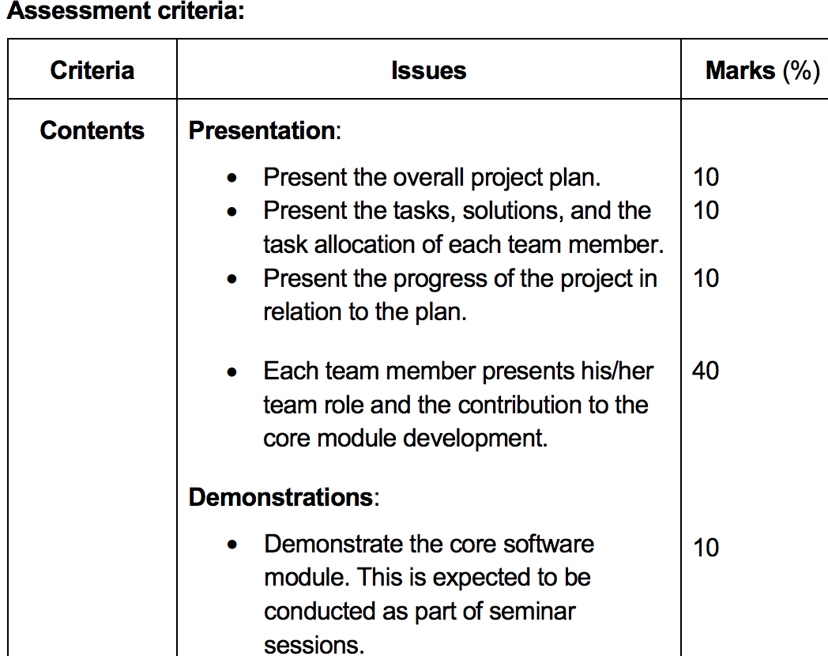

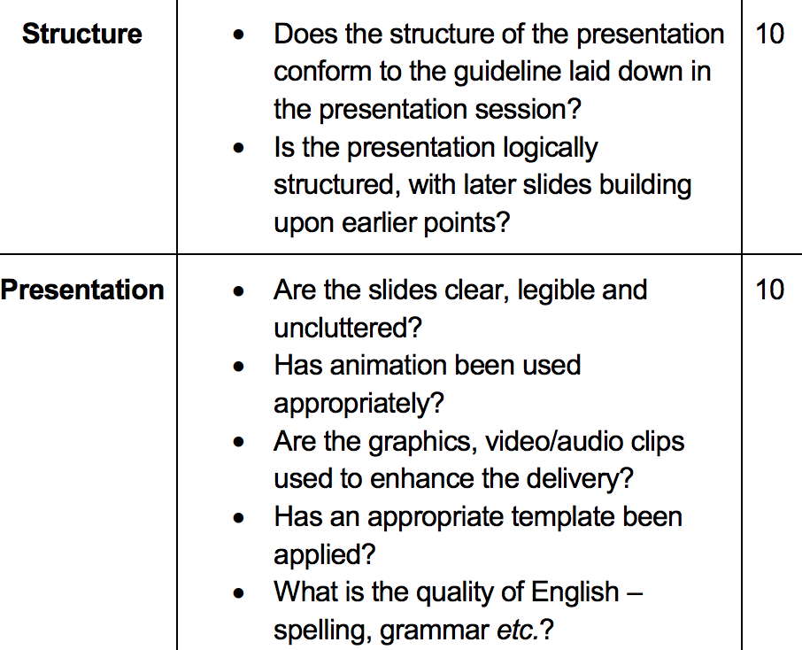

Seems as if there doesn’t need to be a written project plan, etc… documentation, just a PowerPoint presentation.

States “video/audio clips”, I don’t understand what they expect us to deliver in terms of that.